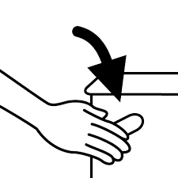

**Pastikan Tandas Kita Sentiasa Bersih**

Please Keep Our Toilet Clean

**Sila Pam Selepas Penggunaan**

**Please Flush After Use**



**Pastikan Tandas Kita Sentiasa Bersih**

Please Keep Our Toilet Clean

**Sila Pam Selepas Penggunaan**

**Please Flush After Use**